A within-country analysis of the relationship between economic development and female labour force participation: micro-level evidence from Mexico

Isaac López-Moreno Flores[1]

**Abstract**

This descriptive paper is the first to provide an overview of the current relationship between female labour participation rates (FLPRs) and different stages of economic development within a country. Its goal is to evaluate a specific hypothesis of the U-shaped female labour force function, which indicates that in middle-income countries like Mexico, low FLPRs are associated with the high percentage of jobs in the industrial sector and a social stigma towards women working in blue-collar jobs. The regression analysis relies on an innovative empirical strategy based on microdata from Mexico’s ENOE household survey. Using repeated cross-sectional data from the first quarters of 2005, 2010, 2015, and 2019, I ran probit regressions to estimate women’s likelihood of being economically active based on the percentage of agricultural, industrial, and service jobs in the municipality where they live. Contrary to the hypothesis, the results show that a higher percentage of industrial jobs at the municipal level is positively associated with higher female labour participation after controlling for individual, household, and municipal characteristics. Moreover, a higher percentage of jobs in the service sector exhibits an even stronger positive relationship. Conversely, women’s probability of being economically active decreases as the percentage of agricultural jobs in the municipality increases. Using disaggregated data I show that the lack of demand for female labour is one of the drivers behind low FLPRs in rural areas of Mexico. Hence, the results reveal a linear relationship between FLPRs and different stages of economic development within Mexico, in contrast with the U-shaped relationship observed across countries.

**Keywords:** Female labour force participation, sectoral distribution of employment, economic development, structural transformation, labour demand

**JEL Codes:** J16, J20, J21, O53

# 1. Introduction

The U-shaped relationship between female labour participation rates (FLPRs) and different stages of economic development has received a lot of attention in recent years. One of the most popular and rigorous papers on this topic highlighted that female labour participation (FLP) is usually high in agricultural countries, tends to decline in countries with a large percentage of jobs in the industrial sector and rises again in countries with service-oriented economies (Goldin, 1994). She developed a whole theory of how the structural transformation process in combination with factors such as fertility rates, educational attainment, marital status, and other sociological and cultural factors, could be playing a role in the U-shaped pattern of FLPRs observed across countries. Since then, other authors have found evidence to support the feminisation U hypothesis (Clark et al, 2003; Heath & Jayachandran, 2016; Mammen & Paxson, 2000; Verick, 2014).

On the other hand, in recent years there have been several critiques of the studies supporting this hypothesis. Gaddis and Klasen (2014) argued that most of the empirical assessments of the U-shaped feminisation hypothesis were based on simple cross-sectional correlations between FLPRs and GDP per capita as a proxy of economic development (eg Psacharopoulos & Tzannatos, 1989; Clark et al, 2003; Verick, 2014; Heath & Jayachandran, 2016). They contended that this approach leads to the ‘Kuznets fallacy’ since the relationship cannot be validated in a time-series context. Moreover, they highlighted various mistakes in the empirical strategy or in the econometric methods that previous researchers had employed to support the feminisation U. They criticised Çağatay and Özler (1995) for not exploiting the panel feature of their data, Mammen and Paxson (2000) for using a static model rather than a dynamic panel method, and Luci (2009) and Tam (2011) for not taking into consideration the potential endogeneity of GDP.

Gaddis and Klasen (2014) also noted that estimates of GDP per capita adjusted at purchasing power parities (PPP) have large margins of error. Therefore, they decided to use ‘sector-specific growth’ as an alternative way of measuring the structural transformation process. Their results indicated that changes in sector-specific growth in agriculture, industry and services have different effects on FLPRs, but that these are small in magnitude, so they concluded that there is little evidence to consider them as key drivers of FLPRs. Nevertheless, they also recognised that some authors might consider their data on sectoral growth to be a ‘noisy’ measure of structural change and that this could bias the coefficients towards zero. However, they argued that their data are “at least as problematic” as the data that had previously been used to test the U-shaped feminisation hypothesis.

In a more recent study, Klasen (2019) argued that this hypothesis would not hold in within-country studies. He presented as an example the study by Lahoti and Swaminathan (2016), which followed a similar approach to Gaddis and Klasen (2014). They examined the U-shaped hypothesis in India using data from 1983 to 2012 and executing a state-level analysis. To do so, they analysed the relationship of FLPRs with net state domestic product (NSDP), as well as with sector-specific growth in value-added and employment across the 28 Indian states. However, they did not find evidence to support the U-shaped hypothesis.

Considering the criticisms of previous research in this area, the goal of this paper is to contribute to the literature by following a different approach. First, instead of doing another cross-country analysis, this is one of the very few papers conducting a within ­­country analysis of the relationship between FLPRs and different stages of economic development within a country. Second, instead of using GDP per capita or sector-specific growth, the paper uses ‘sectoral distribution of employment’ as an alternative measure to capture the different stages of economic development. This indicator is based on three variables that capture the percentage of jobs in agriculture, industry, and services as a share of the total employment in a municipality. Third, instead of using time-series data, the paper relies on micro-data obtained from Mexico’s National Household Surveys on Employment and Occupations, also known as ENOE surveys, which are the main data source for estimating Mexico’s labour market conditions. Fourth, instead of carrying out an economic history analysis to determine whether FLPRs were high when Mexico was an agricultural country, the original contribution of this paper is to show the current dynamics between FLPRs and the sectoral distribution of employment across different municipalities within the country.

It is important to emphasise this last point. This study should not be considered an empirical evaluation of the U-shaped feminisation hypothesis, since the paper is not undertaking a historical analysis of FLPRs when Mexico was an agricultural country. As previously mentioned, the study is based on micro-data from Mexico’s ENOE surveys available from the first quarter of 2005 onwards. According to World Bank data, the sectoral distribution of employment in Mexico during 2005 was 15% in agriculture, 26% in industry and 59% in services. Hence, to evaluate the U-shaped hypothesis in Mexico, it would be necessary to have historical data on FLPRs when most of the jobs in Mexico were in agriculture.

If such an approach had been chosen, this research would have turned into a similar analysis to the previous ones, using time-series data and performing an economic history analysis to make an empirical evaluation of the U-shaped feminisation hypothesis. Instead, I have chosen to follow a different approach that allows me to make an original contribution to the literature. Instead of doing another cross-country analysis, or performing a historical examination of the U-shaped hypothesis starting from Mexico’s agricultural era, this paper shows the current trends on FLPRs in relation to the sectoral distribution of employment across Mexican municipalities. Hence, the major contribution to the literature is that it can be considered a within-country study that offers a snapshot of the current dynamics between FLPRs and the sectoral distributions of employment commonly observed at different stages of economic development.

I also decided to follow this approach to fill a gap in the literature. Klasen (2019) noted that when using cross-country data, it is difficult to disaggregate labour force participation rates to identify and differentiate the level of participation of men and women in each economic sector. Consequently, I performed a within-country analysis using micro-data, since doing so offers a level of disaggregation that cannot be find using time series data or doing cross-country regressions.

One of the limitations of following this approach is that it is necessary to delimit the study to the dates on which data are available. Given that Mexico’s ENOE started in 2005, I discarded the idea of making a long-run analysis and decided to study the current within-country dynamics of FLPRs under different scenarios of the sectoral distribution of employment. Therefore, while the paper takes some of the theoretical underpinnings of the U-shaped feminisation hypothesis, its goal is not to make an empirical evaluation of it. Rather, it is the first study – to the best of my knowledge – to examine the current within-country patterns of FLPRs and different distributions of employment at the local level.

In view of the aforementioned, the research question driving this analysis is to comprehend what the within-country relationship of Mexico's FLPRs entails concerning the sectoral distribution of employment observed at different stages of economic development. To answer the research question, the paper follows an innovative empirical strategy. To execute the micro-econometric analysis, I use the binary variable ‘economically active’ as a proxy of FLPRs. This variable captures the employment status of each individual in the sample, and it takes a value of 1 if they are part of the economically active population, and 0 if they are part of the non-economically active population. It is important to highlight that Labour force participation rates are reported as the percentage of economically active population as a proportion of the working-age population. Therefore, using the variable ‘economically active’ instead of using labour force participation rates, allows me to perform a micro-econometric analysis with a level of disaggregation that cannot be found in previous studies on this subject.

In addition, the paper estimates the sectoral distribution of employment at the municipal level, that in Mexico are considered small subnational territorial divisions below the state level. This is done to explore the relationship of female labour participation with the availability of jobs in agriculture, industry and services in local labour markets. Following this approach, I can run probit regressions restricted to women to estimate their likelihood of being economically active in relation to the sectoral distribution of employment in the municipality where they live, while controlling for individual and household characteristics such as educational level, marital status or the number of children of each woman in the sample.

The results obtained from probit regressions show that women’s probability of being economically active decreases as the percentage of agricultural jobs in the municipality increases. On the other hand, there is no evidence showing that a higher percentage of jobs in the industrial sector has a negative effect on female labour participation. Finally, the results confirm that women’s likelihood of being economically active increases as the percentage of service jobs in the municipality becomes higher. These results represent new evidence for the literature as they contradict some of the hypotheses that have been assumed to be ‘stylised facts’ in this research area. The theory indicates that, in a middle-income country like Mexico, FLPRs should decrease in municipalities with a high percentage of jobs in the industrial sector. However, the results are showing that the agricultural municipalities are the ones with the lowest FLPRs in Mexico.

The paper is structured as follows. Section 2 contains an exploratory data analysis, starting with a brief cross-country analysis and concluding with a within-country analysis that includes relevant statistics about Mexico. Section 3 includes details of the empirical strategy and the dataset. Section 4 presents details of the econometric model and the variables that were considered in the regression analysis. Section 5 presents the results obtained from probit regressions and explores possible explanations for some of the counterintuitive results. Section 6 presents the conclusions of the paper, as well as future research questions on this topic.

# 2 Exploratory data analysis

This section has three different objectives. The first is to show that Mexico is not an outlier of the U-shaped hypothesis in a cross-country comparison. Instead, it is one of the countries that are part of the downward portion of the curve. The second goal is to show that the U-shaped hypothesis holds up in a cross-country analysis after using the sectoral distribution of employment as a proxy for economic development. Finally, it seeks to provide valuable background information about Mexico's background in different statistics that capture the economic situation as well as the labour market characteristics of the country.

### 2.1 Cross-country analysis

Figure 1 illustrates the relationship between FLRPs and the sectoral distribution of employment across countries. The data were obtained from the World Bank and cover 187 countries during 2019. On the left-hand side of the figure are those countries with the highest percentage of jobs in the agricultural sector. They were classified as mainly agrarian if the percentage of jobs in the agricultural sector ranged from 40% to 80%. In the centre of the figure are the top industrial countries, which have more than 30% of jobs in this sector. On the right-hand side of the figure are the service-oriented countries, which have more than 65% of their jobs in this sector. Finally, there are two complementary classifications in the figure. Those classified as agro-industrial have **between** 25% and 40% of their jobs in the agricultural sector, and fewer than 30% of their jobs in the industrial sector. Those classified as industrial-service economies have more than 50% of their jobs in the service sector and fewer than 30% of their jobs in the industrial sector. Although this is an arbitrary classification, it illustrates five different stages of economic development in relation to the sectoral distribution of employment across countries.

**Figure 1: FLPRs and sectoral distribution of employment across countries (2019)**

Mexico

The figure shows that FLPRs are higher in agricultural countries, experience a decline in industrial countries and rise again in service-oriented countries. The Gaussian regression illustrates that there is a U-shaped pattern between the sectoral distribution of employment and FLPRs across countries. Finally, the figure shows that Mexico is part of the downward portion of the U-shaped curve. Three additional scatterplots showing the relationship between FLPRs and the percentage of jobs in each economic sector are included in the appendix (Tables A2–A4). The first shows that FLPRs are higher in countries where there is a greater percentage of jobs in the agricultural sector as a share of total employment. The second shows that FLPRs decrease as the percentage of jobs in the industrial sector increases. Finally, the last scatterplot shows that FLPRs are higher in countries where the service sector accounts for a higher share of total employment. Therefore, these three figures follow the same pattern of the U-shaped hypothesis.

In addition to this evidence, it should also be mentioned that Mexico is the Latin American country with the highest percentage of jobs in the industrial sector, as shown in Figure 2. On the other hand, Mexico is one of the countries with the lowest FLPRs in the region, as illustrated in Figure 3.

**Figure 2: Jobs in the industrial sector as a share of total employment in Latin American countries (2019)**

Source: World Bank, World Development Indicators - Employment in industry (% of total employment).

**Figure 3: Female labour participation rates in Latin American Countries (2019)**

Source: World Bank, WDI – Female Labour Participation (% of female population ages 15+).

This brief cross-country analysis supports the U-shaped hypothesis, since agricultural and service-oriented countries have higher FLPRs than industrial countries. Moreover, since Mexico can be considered a middle-income country with several industrial jobs, it could be inferred that low FLPRs are associated with the high percentage of jobs in the industrial sector and the social stigma towards women working on blue-collar jobs. However, a closer examination of Mexico's within-country data shows that the low FLPRs in the country are not necessarily linked to the high percentage of jobs in the industrial sector.

### 2.2 Within-country analysis

As discussed above, Mexico has one of the lowest FLPRs in Latin America. Unfortunately, not utilizing this female human capital implies a significant economic loss. Cuberes and Teignier (2018) estimated that the Mexican gender gap in labour force participation is leading to an economic loss of 22% in the final output of GDP. Therefore, understanding the reasons behind this phenomenon is relevant not only to the empowerment of women but also to promoting economic growth. In fact, the rise in FLPRs has been identified as one of the main factors driving the growth miracles in East Asian countries (Bloom & Williamson, 1998; Bloom et al., 2009; Bloom & Finlay, 2009).

Kaplan & Piras (2019) analysed gender gaps in Mexico’s labour markets and found that the country has the second largest gender gap in labour force participation in Latin America. They noted that it has the sixth highest male labour participation rate in the region, while the FLPR is the fourth lowest. They argued that one of the reasons behind low FLPRs in Mexico is the high percentage of young women who neither study, work nor are looking for a job: that figure is the fourth highest in the region (only lower than in Guatemala, Honduras and El Salvador), while the percentage of young men in the same condition is the lowest in the entire region. Moreover, they highlighted that the labour force participation of single or divorced women is similar to that in other Latin American countries, but the participation rate of married women is the lowest in the region. In addition, they showed that Mexican women with high levels of education have lower labour participation rates compared to other countries in the region. For example, the participation rate for women with at least 14 years of schooling is the second lowest in the region (only higher than Bolivia’s). Finally, they showed that Mexican women have the highest number of hours dedicated to unpaid work in Latin America.

Even though these factors are usually determinants of female labour participation, there is still scant evidence of how the sectoral distribution of employment at the local level affects women's ability to supply labour. The purpose of this study is to fill this gap by analysing how the distribution of jobs in agriculture, industry and services relates to the likelihood of women participating in labour markets. This sub-section therefore includes different figures that show key labour statistics from Mexico during the past few years.

It is important to start by emphasising that Mexico has made progress in its economic development process during the last decades. This can be observed in Figure 4, which captures the structural transformation of the country from 1991 to 2019, as well as FLPRs during the same period. The figure shows that the industrial sector has accounted for around 25% of total employment over the past 30 years. During the same period, there is also a decline of 10 percentage points in agricultural jobs and a rise of 10 percentage points in services. The figure thus shows that in recent decades Mexico has maintained its levels of industrialisation, decreased its agricultural activities, and increased the size of the service sector, which accounts for more than 60% of the total employment share. Finally, the figure also shows that female labour participation rates have increased by more than 10 percentage points during the same period.

**Figure 4: Structural transformation and female labour participation in Mexico (1991–2019)**

Source: World Bank, World Development Indicators.

Figure 5 presents a map with the sectoral distribution of employment in the 32 states of the country during 2019. Several aspects of this figure should be noted:

1. Mexico City is a service-oriented economy with more than 80% of jobs in this sector, similar to economies like Singapore, Macao and Hong Kong.
2. The purple-coloured states have more than 60% of jobs in services and 25% in industrial activities, which is similar to countries like Austria, Germany and Russia.
3. The light-blue states have a service-oriented economy but with less industrial employment than in the purple states. These states have a sectoral distribution of employment similar to countries like Colombia and Paraguay, where the share of employment in agricultural and industrial activities is roughly the same.
4. The yellow states have between 25% and 38% of their jobs in industrial activities, similar to Central European countries like Serbia, Romania, Poland and Slovenia.
5. The orange states are those with the highest rates of agricultural employment. In these states, there is a higher number of people working in the agricultural sector than in the industrial sector, and they have a similar sectoral distribution of employment to countries like Guatemala, Mongolia, Ecuador and Nigeria, where at least 20% of the workforce is engaged in agriculture.
6. The map shows that most of the yellow states are in the of the country. These states are oriented to industrial activities, since they contain plenty of *maquiladoras* dedicated to the manufacturing sector.
7. The south of the country is more agriculture-oriented and in many cases also has higher poverty rates.

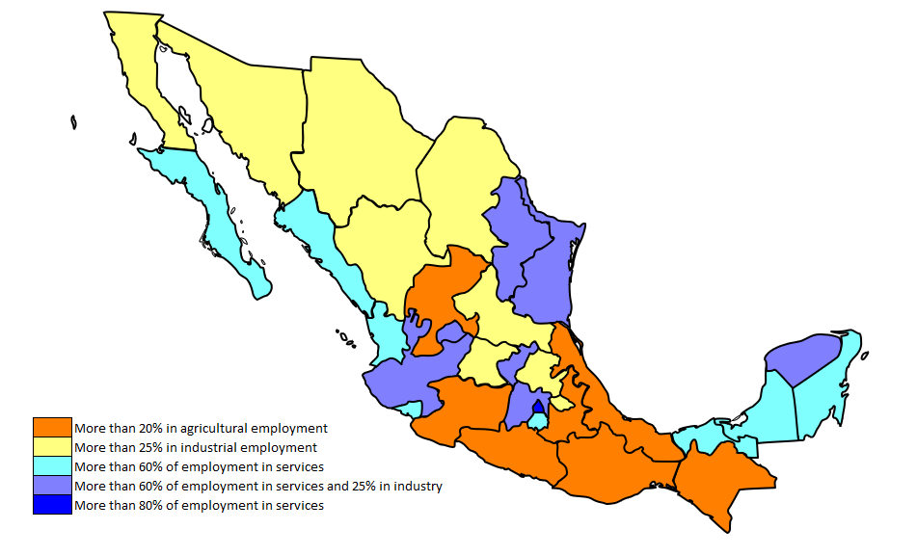**Figure 5: Map of the sectoral distribution of employment in Mexican states (2019)**

In addition, it is important to illustrate the relationship between economic development and the engagement of women in labour markets. To do so, Figure 6 shows FLPRs and the percentage of jobs in agriculture, industry and services for each Mexican state, while Figure 7 shows the relationship between the same indicators but at the municipal level. The data were obtained from the ENOE survey, based on the first quarter of 2019. The scatterplots on the left show that FLPRs are lower in states and municipalities where there is a higher share of agricultural employment. Those in the centre do not show the alleged negative relationship that a higher percentage of industrial jobs would have on FLPRs. Finally, the scatterplots on the right show that FLPRs are higher in states and municipalities with a higher percentage of jobs in the service sector.

**Figure 6: FLPR and % of jobs in each economic sector (Mexican states, first quarter of 2019)**

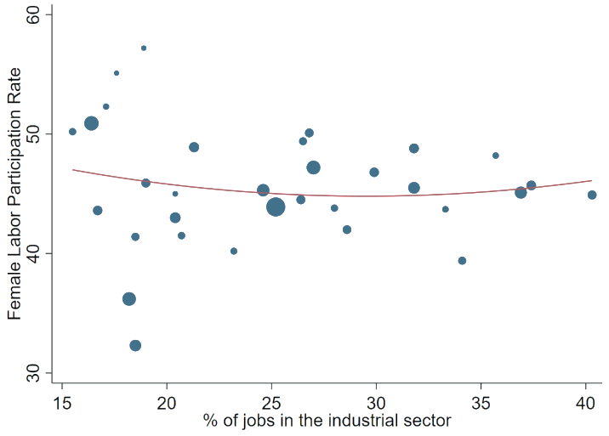

Note: The size of the dots varies depending on the total population in each state.

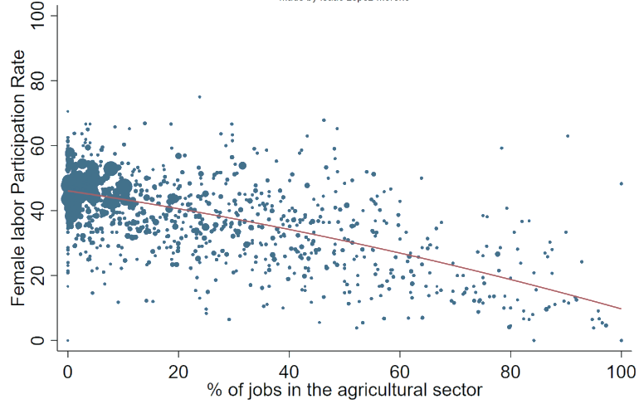**Figure 7: FLPR and % of jobs in each economic sector (Mexican municipalities, first quarter of 2019)**

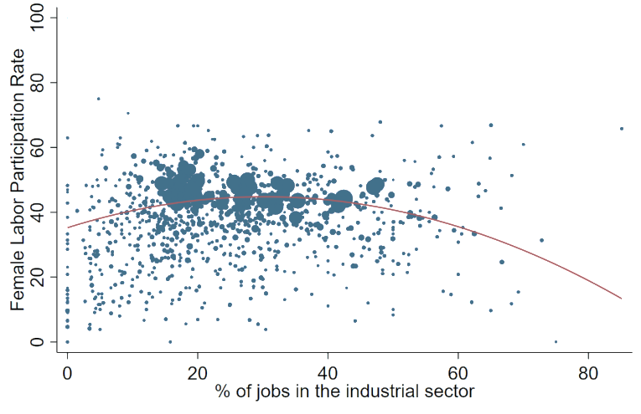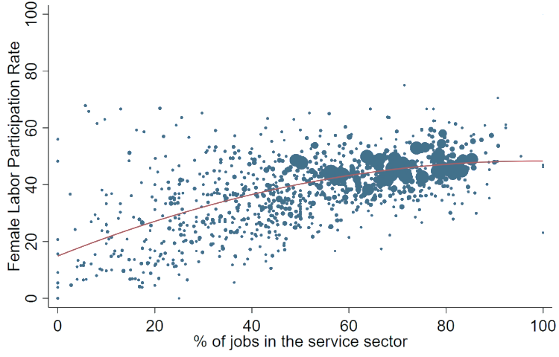

Note: The size of the dots varies depending on the total number of surveys carried out in each municipality.

The above figures do not show the same dynamic observed in cross-country comparisons. However, they make sense after looking at other labour market statistics for Mexico. Figure 8 shows the proportion of men and women participating in different economic activities during the first quarter of 2019. The data indicate that women only account for 11% of the total employment in the agricultural sector. In addition, they show that women make up more than 36% of the total workforce in the manufacturing sector. In both cases, the statistics do not match some of the premises of the U-shaped hypothesis. As mentioned above, the theory suggests that women are not usually involved in the manufacturing sector, while they tend to be engaged in agricultural activities. On the other hand, some of the statistics are in line with the U-shaped hypothesis. For instance, the figure shows that women have higher participation rates in several white-collar jobs: health services, education, financial services, as well as lodging and food and beverage preparation.

**Figure 8: Percentage of men and women working in different economic activities  
(Mexico, 2019 Q1)**

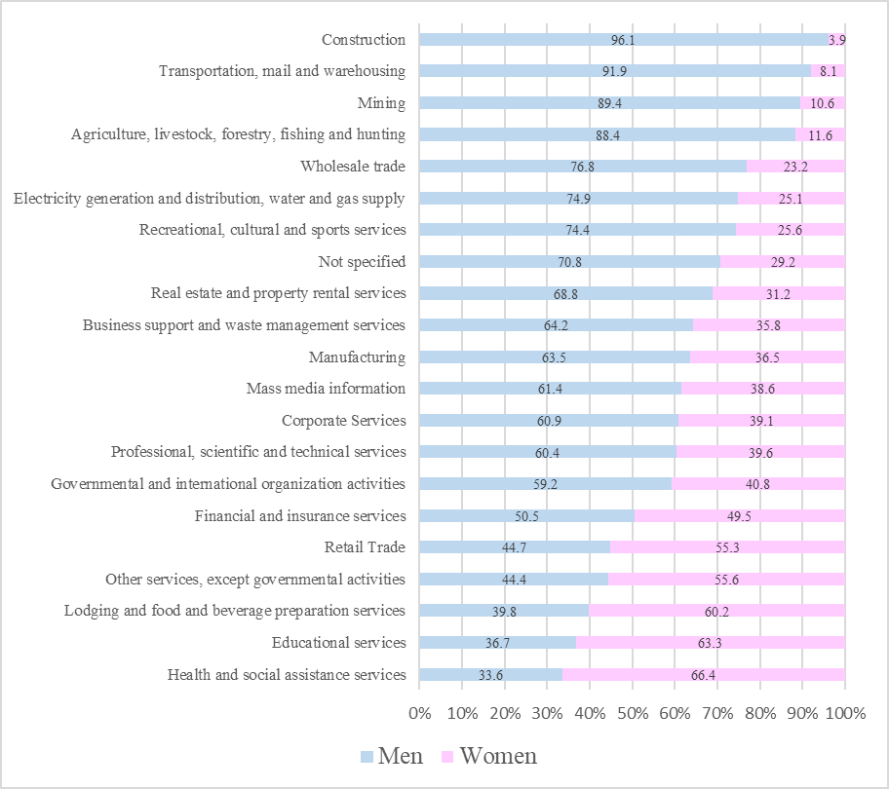

Finally, Figure 9 shows the percentage of men and women employed in different economic activities as a share of these activities’ total workforce. In the case of women, retail trade is the main source of employment while the manufacturing sector comes second. At the other end of the scale, very few women are working in the mining and construction sector, as established in the U-shaped feminisation hypothesis. Moreover, the data indicate that more than 25% of women are engaged in white-collar jobs. Finally, the figure shows that the participation of women in agriculture is particularly low, since less than 4% of female workforce have an economic activity in this sector.

**Figure 9: Main occupations for men and women as a share of their total workforce, Mexico (2019 Q1)**

To recapitulate, this section has shown that, in a cross-country comparison, Mexico is part of the downward portion of the U-shaped curve. It also reveals that Mexico is the latin-american country with the highest percentage of jobs in the industrial sector, but that it also has one of the lowest FLPRs in the region. Finally, the within-country analysis shows that some of the premises of the U-shaped hypothesis do not hold in Mexico (eg the alleged negative relationship between a higher percentage of industrial jobs and lower FLPRs). The next sections include details of the empirical strategy and the econometric model that was executed to analyse the relationship between the sectoral distribution of employment and FLPRs after controlling for other variables that could be related with the engagement of women in labour markets.

# 3 Empirical strategy

This section outlines various fundamental aspects regarding the empirical strategy implemented to conduct my research. It commences with a description of the databases utilised, followed by an explanation of how I estimated the sectoral distribution of employment at the municipal level.

### 3.1 Dataset description

Most of the studies that have analysed the U-shaped hypothesis are based on macro-level data. However, this study uses micro-level data obtained from the extended version of the ENOE survey, which is carried out by the National Institute of Statistics and Geography (INEGI), Mexico’s national statistical office. The ENOE surveys are the main source of information for most of the labour market statistics for the country. They were introduced in 2005 and collect employment statistics in monthly or quarterly periods by making household surveys. The sample in each dataset is large enough to adequately represent rural and urban areas in each of Mexico's 32 states. In addition, the surveys include information on the labour status of individuals and also integrate socio-demographic information like educational level, marital status, number of children and access to social security, among others.

It is important to emphasise that, during the first quarter of each year, INEGI conducts an amplified survey, while in the second, third and fourth quarters, it conducts a basic survey. Therefore, this study considered four cross-sectional datasets using the ENOE surveys from the first quarters of 2005, 2010, 2015 and 2019. I chose to utilize surveys from the first quarter of these years because they provide the most detailed information, whereas surveys conducted during the other three quarters omit specific questions that are exclusively available in the amplified survey.

Although there is usually a five-year difference between the selected surveys, I used the survey from the first quarter of 2019, since the Covid-19 pandemic had a great impact on female labour participation, and also because no survey was conducted during the first quarter of 2020. Finally, the study uses the five-year intervals to capture the changes in the sectoral distribution of employment across Mexican municipalities during the past 15 years. Such period spanning illustrates both the structural transformation of local economies and the changes in female labour participation over the years.

### 3.2 Estimation of the sectoral distribution of employment at the municipal level

One of the main points to highlight from the empirical strategy is that I estimated the sectoral distribution of employment at the municipal level in order to use it as a proxy of economic development at the local level. The sectoral distribution of employment is based on three main variables, namely the percentages of jobs in agriculture, industry and services as a share of the total employment in each municipality. Previous studies analysing the feminisation U-shaped hypothesis have used GDP per capita, as well as sector-specific growth in value-added or in employment as a proxy of the structural transformation process. As previously explained, Gaddis & Klasen (2014) criticised the studies that used GDP, proposing ‘sector-specific growth’ as an alternative variable to test the U-shaped hypothesis. However, they recognised that this variable might raise concerns among some researchers because it could be considered a noisy measure of the structural transformation process.

Because of the lack of consensus on this subject, my research proposes an alternative way to analyse the relationship between FLPRs and different stages of economic development. As stated above, Goldin (1994) implied that the proportion of jobs at the local level has an influence on FLPRs. She argued that in agricultural economies women participate in the labour market to a great extent, while in countries with a high percentage of jobs in industry, FLPRs decline. Finally, she argues that FLPRs rise again during the expansion of the service sector, as there is no social stigma attached to white-collar jobs.

Based on the previous explanation, my research considers that the percentage of jobs in each economic sector is an appropriate variable to capture both the structural transformation process and the different stages of economic development across time. This is in line with Perkins et al (2013) who argued that, at the lowest levels of income per capita, agriculture dominates both as a share of GDP and as a share of total employment. However, when the industry and the service sectors start growing, agriculture will account for a smaller share of both GDP and total employment. In addition, I argue that sector-specific growth does not necessarily reflect the stage of the structural transformation process. For example, in a low-income country where most of the jobs are in the agricultural sector, there might be employment growth in the industrial sector at some point, but that does not mean that the industrial sector is already more important than the agricultural sector. Therefore, the structural transformation should be measured in relation to the size of each sector as a percentage of total employment.

To estimate the sectoral distribution of employment at the municipal level, I considered all individuals who reported being employed within each municipality, regardless of their sex. After doing this, I used the ‘expansion factor’ provided by INEGI to indicate the weight of each individual in the sample. More precisely, the ENOE household survey indicates that the ‘expansion factor’ can be interpreted as the number of units in the population that each unit in the sample represents. For instance, if a person in the sample is categorised as ‘employed’ and their ‘expansion factor’ is equal to 308, this means that there are 308 employed people in Mexico with the same socio-demographic characteristics. Hence, ‘expansion factor’ is a variable that assigns a certain weight to each individual in the sample, and it can be used to obtain more precise estimations.

It is important to mention that the individuals interviewed in household surveys are selected through a random process and they also have different probabilities of selection. Hence, National Statistical Offices estimate the weight of each individual in the sample, which is equal to the inverse of the probability of being sampled. Omitting these sampling weights leads to biased estimates, which are far from the true values. Consequently, using sampling weights is useful to have a more precise estimation of the percentage of jobs in agriculture, industry and services at the municipal level.

One of the main advantages of using the weight variable (ie the expansion factor), is to have a more precise estimation of the people living in rural areas. Table 1 shows a comparison between the respondents from rural and urban areas in comparison with the estimations of the urban and rural population in Mexico after using the weight variable. The table shows that there is a higher proportion of respondents from urban areas than from rural areas. However, after using the weight variable the estimations show that there is a higher proportion of people living in rural areas than in urban areas.

**Table 1: Rural and urban respondents compared with rural and urban populations**



One of the main limitations of using the weight variable is that the ENOE survey is not representative at the municipal level, so the biggest municipalities are more likely to have a precise estimation of the sectoral distribution of employment, as they have a larger sample size. Meanwhile, the small municipalities will have larger measurement errors, as they have fewer respondents. Nevertheless, I have addressed this concern to a certain degree by devising a novel approach. After estimating the percentage of jobs in agriculture, industry and services for each municipality in the sample, all the individuals who were surveyed in municipality *x* get the corresponding values of the sectoral distribution of employment in that municipality. Therefore, if they live in a small municipality, where only a few people report having a job, the estimation may be less reliable, but their weight in the total sample will also be smaller. For instance, each ENOE survey considered for this analysis had more than 300,000 respondents. Thus a municipality with more than 8,000 employed individuals has 100 times more weight in the sample than a municipality where only 80 employed individuals answered the survey.

Despite recognising the innovation inherent in this empirical strategy, it is important to note that it is also a modest solution. Having a precise estimate of the sectoral distribution of employment at the municipal level would require the use of Small Area Estimation Methods, which is beyond the scope of this research. Nevertheless, I want to highlight the relevance of the weight variable to provide precise estimations of the sectoral distribution of employment. In the appendix I include three figures showing a comparison between the estimations of the sectoral distribution of employment at the state level during the first quarter of 2019 (Figures A5–A7). These include the official statistics published by INEGI, as well as my estimations using and not using the weight variable. These figures illustrate that, if the weight variable is not employed, the agricultural sector is underestimated, while the service sector tends to be overestimated. They also show that the estimations obtained using the weight variable are very similar to the official statistics published by INEGI. The figures demonstrate the utility of the weight variable at estimating the sectoral distribution of employment at the state level. Nonetheless, it is imperative to note again that the ENOE surveys are not representative at the municipal level.

# 4 Econometric model

To analyse the relationships between FLPRs and the sectoral distribution of employment at the municipal level, I assume that the probability of being economically active can be characterised by this probit model:

where *i* ∈ {1, ... , *N*} is an index for individuals, *m* ∈ {1, ... , *M*} is an index for municipalities, *t* ∈ {2005 1Q, 2010 1Q, 2015 1Q, 2019 1Q} is an index for the specific years and quarters considered for this study, *s* ∈ {agriculture, industry, services} is an index that captures the percentage of jobs in each economic sector, and *e* ∈ {1, ... , *32*} is an index for the 32 states in Mexico. Finally, represents the fixed effects included in the model.

*Y* is a binary variable that captures whether a woman is part of the economically active population or not. This is the dependent variable of the model, and it takes a value of 1 if a woman is economically active and 0 if she is part of the non-economically active population. According to both the International Labour Organization (ILO) and INEGI, the labour force participation rate should be estimated by considering individuals who are over 15 years old. This approach helps to determine the proportion of the working-age population that is either employed or actively seeking employment, also known as the ‘economically active population’. On the other hand, INEGI considers that people who are attending an educational institution or who are retired, as well as people engaged in household duties, or who are infirm or disabled, are part of the non-economically active population. Based on the previous explanation, using ‘economically active’ as a dependent variable seems to be an accurate way of analysing the relationship between FLPRs and the sectoral distribution of employment at the municipal level.

*Share* is the main independent variable of the model, and it captures the percentage of jobs either in agriculture, industry or services as a share of total employment in each municipality in a certain year. Moreover, is the coefficient of interest throughout the paper; it captures the positive or negative relationship of the sectoral distribution of employment in the likelihood that a woman is part of the economically active population.

is a vector of potential explanatory variables that control for the individual characteristics of each woman in the sample. The first two controls are age and ‘age squared’ since the relationship between labour status and age is usually non-linear. I also control for educational attainment, which is a categorical variable that captures the highest level of education each woman in the sample has obtained. The literature on this topic indicates that the relationship between a woman’s level of education and her participation in labour markets differs across countries, so it is incorrect to assume a positive and linear relationship.

Klasen et al. (2021) offer an overview of this research subject and provide micro-level evidence on the differences in this relationship after analysing eight developing countries. They explain that, in some developing countries, educational attainment and female labour participation show a U-shaped pattern. This can be explained after considering that, in these countries, women with the lowest levels of education are usually engaged in subsistence activities and informal employment, while those with an average level of education may be able to afford to stay out of these subsistence activities. However, other countries show a common linear relationship.

Figure A1 in the appendix shows that Mexican women with low levels of education have the lowest labour participation rates, while highly educated women have the highest rates (first chart). Therefore, educational attainment is included in the model as a control variable that seems to have a positive and linear relationship with female labour participation.

Another control variable included in the model is the marital status of each woman, since Goldin (1994) explained that married women are usually less likely to work. Surprisingly, the second chart in Figure A1 in the appendix shows that in Mexico married women have higher labour force participation rates than single women. However, this makes sense after considering that the dataset includes all women above 15 years old, so a considerable proportion of single women in the sample are teenagers who are still studying in high school or university. Finally, the third chart in the figure also indicates that divorced and separated women have the highest labour force participation rates in Mexico over the years.

The econometric model also includes a control variable that captures the socioeconomic stratum of each respondent. This is a categorical variable that considers people from low, medium-low, medium-high and high socioeconomic strata. INEGI (2020) indicates that this variable is built using multivariate statistical methods based on 34 indicators that capture the economic situation of the individuals, as well as the physical characteristics and the equipment in their households. Some of the indicators considered are access to medical services, educational attainment, illiteracy, a solid floor in the household (cement, wood, mosaic), overcrowding in the household, access to electricity, water and drainage piping as well as possession of items such as televisions, cars, cell phones, refrigerators and washing machines.

Based on the previous explanation, I consider that the variable ‘socio-economic stratum’ can be used as a proxy for the financial situation of the individuals in the sample, and I included it as a control variable because there is an interesting debate on this topic. Goldin (1994) argues that married women engaged in physically demanding jobs are usually perceived by society as a bad reflection of their husband’s ability to be the sole provider for the family, while they also tend to be judged as negligent spouses. Borrowman and Klasen (2017) also found evidence in developing countries to support the idea that non-white-collar jobs are frequently considered unsuitable for women. However, they also found that this stigma is not relevant in households where both the woman and her husband are poorly educated; their interpretation is that the stigma is probably ignored in the poorer households, which usually have urgent economic needs. This is in line with Verick (2014), who argued that poor women in low-income countries are the most likely to participate in the labour market, usually in subsistence activities and informal jobs. On the other hand, Lampietti and Stalker (2000) found that, in six out of the nine Latin American countries they considered, poor women had lower FLPRs than non-poor women. For the case of Mexico, the third chart in Figure A1 in the appendix shows that women from low socioeconomic strata have the lowest FLPRs across time. In the next section of the paper, I explore possible explanations of why this is happening in Mexico.

The model also includes a control variable that captures the number of children that each woman in the sample has given birth to. The second chart in Figure A1 in the appendix shows that women without children have similar FLRPs to married women. This could be counterintuitive, since women without children are usually more likely to work, as they do not have a care burden. However, it is important to emphasise – once again – that many women who do not have children are teenagers or young women who are still attending school. As mentioned above, the sample considers every woman above 15 years old, as this is the proper way of estimating labour force participation rates.

is a vector of control variables that captures different characteristics of the place where the subjects live. The control variables that capture characteristics at the municipal level were obtained after using the weight variable that the ENOE survey assigns to each individual in the sample. These control variables at the municipal level are included in the model to ensure that the relationship between the dependent variable (FLP) and the main independent variable (sectoral distribution of employment) is not spurious or biased. Therefore, we can test whether the relationship is statistically significant after accounting for other variables that capture the characteristics of the municipality and that could be correlated with the dependent variable or the main independent variable of the model.

Some of the control variables at the municipal level are:

* average age of women in the municipality;
* percentage of women in the municipality with elementary schooling or less;
* percentage of women in the municipality with secondary schooling;
* percentage of women in the municipality with high-school education;
* percentage of single women in the municipality;
* percentage of women in the municipality who are married or in a free-union relationship;
* percentage of people in the municipality from a low socioeconomic stratum;
* percentage of people in the municipality from a medium-low socioeconomic stratum;
* average number of sons or daughters among women between 20 and 35 years old, used as a proxy of the fertility rate in the municipality.

Apart from these control variables at the municipal level, I also included a control variable that captures the percentage of people in the municipality who have migrated from their city or locality to keep or obtain their current job, since within-country migration is easier than migration across countries.

Finally, I included two control variables that capture the characteristics of the place where the respondents live, but not at the municipal level. The first is a dummy variable that indicates whether the individual lives in a rural or urban area. The second is a categorical variable that captures the population size of the locality where the respondent lives. This variable considers four categories: 1) localities with more than 100,000 inhabitants; 2) those with between 15,000 and 99,999 inhabitants; 3) those with between 2,500 and 14,999 inhabitants; and 4) those with fewer than 2,500 inhabitants.

These two variables were included in the model because there are municipalities in Mexico where the surveyed participants could be living in rural parts of a given municipality, while other respondents live in urban areas in the same municipality. In other words, a municipality in Mexico can have both rural and urban areas within its territorial demarcation. Moreover, Mexican municipalities also have several localities, so there are respondents from the same municipality that could be living in localities with different population sizes.

These two variables are included in the model because various studies have identified them as explanatory variables of FLPR. For instance, according to the estimates obtained by López-Acevedo et al. (2021), residing in a Mexican urban household is linked with an 11.1 percentage point increase in woman’s likelihood of being employed in both 2007 and 2017. Therefore, including this dummy variable as a control is particularly relevant, especially because it can also be correlated to the estimations of the sectoral distribution of employment, since rural areas tend to be agriculture-oriented, while urban areas usually have a higher percentage of jobs in industry and services. Moreover, Falk and Leoni (2010) found that population density is positively associated with FLPRs in Austria. They interpreted this to be because densely populated areas provide a larger and better array of employment opportunities for female workers. Therefore, I included the locality size as a control variable that can be used as a proxy for population density in Mexico.

The descriptive statistics of all the variables considered for the econometric model are presented in Table A1 of the appendix.

# 5 Results

The estimation results that capture the relationship between the sectoral distribution of employment and female labour participation are presented in Table 2. These are based on four cross-sectional datasets that capture the labour statistics of Mexican households in the first quarters of 2005, 2010, 2015 and 2019. The results were obtained after running probit regressions that estimate whether the percentages of jobs in agriculture, industry or services at the municipal level have a positive or negative relationship with women’s likelihood of being economically active. The regressions are restricted to women at least 15 years old, since this is the legal age to start working in Mexico and it is also used by INEGI and ILO as the minimum age for estimating FLPRs. All regressions were run using probability weights and they include fixed effects at the state level to control for unobserved heterogeneity across the 32 federal entities. Finally, the standard errors are clustered at the municipal level, since the sectoral distribution of employment and the control variables at the local level were estimated using as a reference the territorial divisions of Mexican municipalities.

The results show that a higher percentage of agricultural jobs at the municipal level is negatively associated with a woman’s likelihood of being economically active. In addition, they indicate that a higher percentage of jobs in the industrial and service sectors at the municipal level is positively associated with a woman’s likelihood of being economically active. This indicates that women living in agricultural municipalities are less likely to be part of the labour force. On the other hand, the probability that a Mexican woman is economically active increases if she lives in a municipality where the industrial or service sector is more relevant than the agricultural sector.

Although it is not possible to make causal claims from these results, it is important to emphasise that the variables capturing the sectoral distribution of employment at the municipal level are statistically significant after controlling for both the individual characteristics of women, as well as the characteristics of the place where they live. Therefore, the results suggest that the percentage of jobs in agriculture, industry and services are potential explanatory variables of female labour participation in Mexico.

Moreover, the interpretation of these results suggests that Mexico does not seem to have a relevant social stigma towards blue-collar jobs. Further, there is no evidence to indicate that the high percentage of jobs in the industrial sector has a negative effect on FLPRs. The results suggest that one possible explanation for the low levels of female labour participation in Mexico is that women living in agricultural communities are very unlikely to work. Finally, it should be noted that individual characteristics seem to be more relevant in predicting women’s likelihood of being economically active than is the sectoral distribution of employment.

**Table 2: Probit regressions to estimate the likelihood that a woman is economically active  
based on the sectoral distribution of employment in the municipality where they live**





### 5.1 Potential concerns and future robustness checks

Before moving to the conclusions of the paper, I will address some potential concerns with the above results. One such is that female labour participation in Mexico's agricultural sector is not being accurately measured, which could explain the low rates of such participation in this sector. One of these concerns could be that women who reported being engaged in agriculture only for their own consumption might not have been counted as economically active. However, INEGI (2015) established that a person working in agriculture for self-consumption purposes is consider part of the economically active population.

Another possible concern is that some women are not being counted as economically active because they are simply ‘helping’ with agricultural activities. However, according to INEGI’s criteria, those individuals who answer that they are only helping the family business without receiving a salary are categorised as ‘unpaid workers in family businesses’, and they are considered part of the economically active population even if they are not receiving a salary. In addition, INEGI also considers that an individual is economically active if they are self-employed or own-account workers. Therefore, there are no signs of a potential underestimation of women’s participation in agricultural activities.

To conclude this section, I want to mention some of the robustness checks that could be included in future versions of this paper. As explained earlier, the dependent variable used in this study considers all women over 15 years old, as this is how INEGI as well as ILO measure the economically active population and build the estimations of FLPRs. However, I think it would be more appropriate to run regressions considering only women between 18 and 65 years old. By doing so, the sample would exclude young teenagers who are probably attending school, as well as older women who are probably no longer working. Once this is done, it would be interesting to analyse whether the relationship between the sectoral distribution of employment at the municipal level and FLPRs remains statistically significant and whether there are significant changes in the coefficients. This would be a similar approach to the one followed by Bhalotra and Fernández (2021), who restricted their sample to workers between 25 and 55 years old, to diminish the selection problems resulting from changes in educational levels across younger generations as well as the retirement decisions of older generations.

It is also important to highlight a recent finding by Deshpande & Singh, (2021). They found that during a household survey women may be less likely to disclose their job search compared to men, as they often look for informal or temporary jobs, which may lead them to omit mentioning that they are looking for a job. This could affect the estimation of labour force participation rates, which includes individuals who are both employed or actively seeking employment. Since the indicator could be biased, it would be interesting to use a slightly different independent variable. For instance, I could use a dummy variable that takes the value of 1 if the woman is working and 0 if they do not work or if they are looking for a job. I anticipate little variation in the results, but I also think it is something that should be noted.

Another robustness check in future iterations of this paper would involve examining different quarters of the year. As mentioned, the paper only used data from the first quarters of 2005, 2010, 2015 and 2019. Therefore, including data from other quarters could provide interesting insights, especially given that the agricultural sector is highly susceptible to fluctuations in labour demand as a result of seasonal variations in crop harvesting. Consequently, examining female labour force participation rates in agricultural municipalities during different quarters of the year might reveal important patterns. In addition, I would like to include the variable developed by López-Acevedo et al (2021), which estimates the availability of childcare centres at the municipal level, to check the robustness of my results. Finally, another robustness check would involve following the same empirical strategy but using data from Mexico’s census for 2010 or 2020, since these are representative at the municipal level.

### 5.2 Discussion: the role of lack of female labour demand

As mentioned above, one of the most striking results from this research is that female labour participation tends to decline in agricultural municipalities of Mexico. There are different factors that could explain this phenomenon. One is the role that agricultural machinery is playing in the lack of demand for female labour in agricultural activities. Goldin (1994) noted that, during the structural transformation process, changes in agricultural technology and the introduction of agricultural machinery tend to displace female workers engaged in labour-intensive agricultural activities. This is in line with the findings of Afridi et al. (2020), which showed that technological changes in agriculture led to a significant decline in demand for women’s labour on farms in India. Bearing this in mind, a potential explanation of low FLPRs in agricultural municipalities is because Mexico has an agricultural sector that is capital-intensive, while the agricultural sector in low-income countries tends to be labour-intensive.

In a recent study, Deshpande and Singh (2021) found that the decline of FLPRs in India is a consequence of a lower demand for female workers. Their results show that the decline is not necessarily happening because women are voluntarily dropping out of the labour force thanks to an income-effect, or because they are not participating as a result of conservative social norms. Instead, they show that it is the result of the unavailability of steady gainful employment. Following an analogous line of reasoning, I decided to examine whether women’s low labour force participation rates in agricultural activities were related to the lack of female labour demand in this sector. To do so, I used remarkable data obtained from different questions in the ENOE survey.

In the questionnaire, there are two key questions that can be used to estimate where in the country the lack of labour demand is affecting FLPRs. The first question asks non-economically active respondents what their main activity is. This question helps identify those individuals who are non-economically active because they are retired, studying, dedicated to household chores, or because they have a disability. Furthermore, the second question helps identify the primary reason for their economic inactivity. The options are:

1. I am waiting for a response to an application, or an employer will call me soon.
2. There is no work in my field my field, occupation or profession.
3. I do not have the necessary schooling, documentation or experience to perform a job.
4. I think that because of my age or my appearance I wouldn't be accepted for a job.
5. In my locality there are no jobs, or they are only available during certain seasons of the year.
6. Public insecurity or excessive paperwork are discouraging me from starting an economic activity.
7. I'm recovering from an illness or accident.
8. I'm pregnant.
9. I have no one to take care of the children, elderly or sick people in the household.
10. A relative is not letting me work.
11. Other market reasons.
12. Other personal reasons.

Using these variables, I decided to execute an exploratory data analysis to examine whether low FLPRs in Mexico’s agricultural municipalities can be explained by a lack of female labour demand. The analysis was restricted to working-age women classified as non-economically active and who indicated that they were not working or looking for a job because they were dedicated to household chores.

Figure 10 offers different insights about the main reasons why women with these characteristics are not working. First, it shows that in 2019 the primary cause for not working was because they did not have anyone to help them take care of their children, or of elderly or disabled people living in the household. The second reason was that there were no jobs in their locality, or these were only available during certain seasons of the year. Figure 11 shows that almost all women who are not working as a result of lack of demand for their labour tend to live in rural areas. Figure 12 shows the responses of all women who selected the labour demand option across all the ENOE surveys available from 2005 to 2019, and confirms that almost all women who selected this option are living in rural areas. Figure 13 shows that in localities with more than 100,000 inhabitants the lack of labour demand is not a problem, but in small localities with fewer than 2,500 inhabitants more than 25% of working age women indicated that they are not working because of the lack of labour demand. Finally, Figure 14 shows that, on average, the agricultural sector is the most relevant in localities with fewer than 2,500 inhabitants, accounting for more than 40% of total employment.

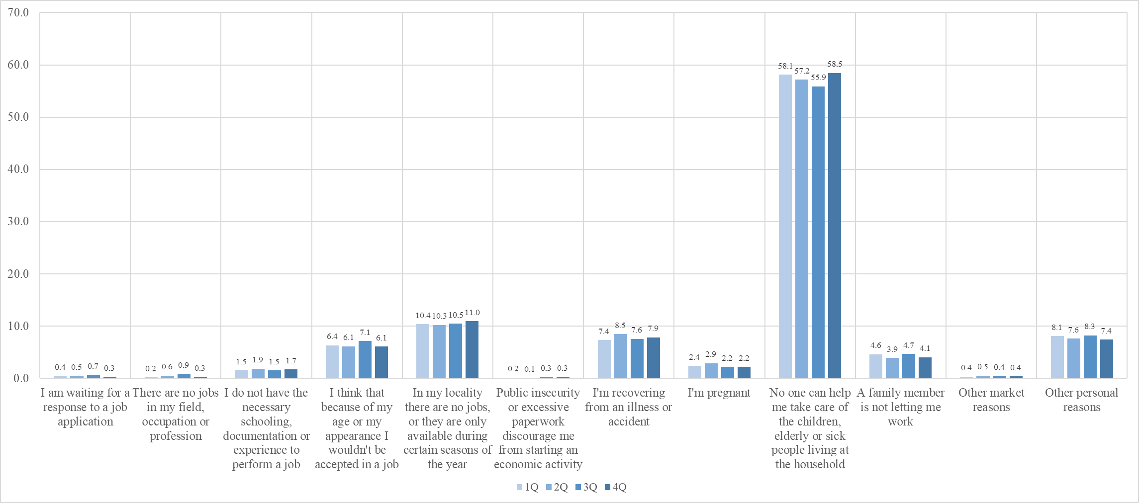**Figure 10: Reasons for not working among working-age women (18–65) who are engaged in domestic chores, Mexico (2019)**

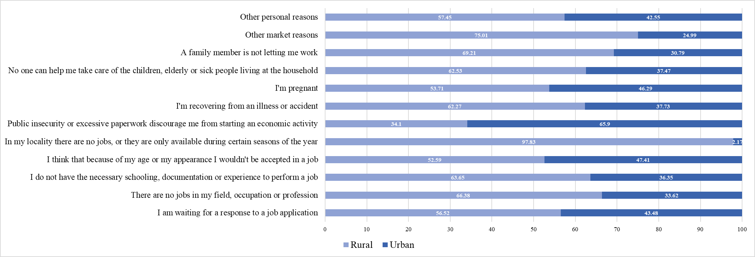**Figure 11: Reasons for not working among working-age women (18–65) engaged in domestic chores,   
differentiated by urban and rural areas (Mexico, first quarter of 2019)**

**Figure 12. Non-working women as a result of lack of labour demand, differentiated by urban and rural areas   
(Mexico, 2005–2019)**

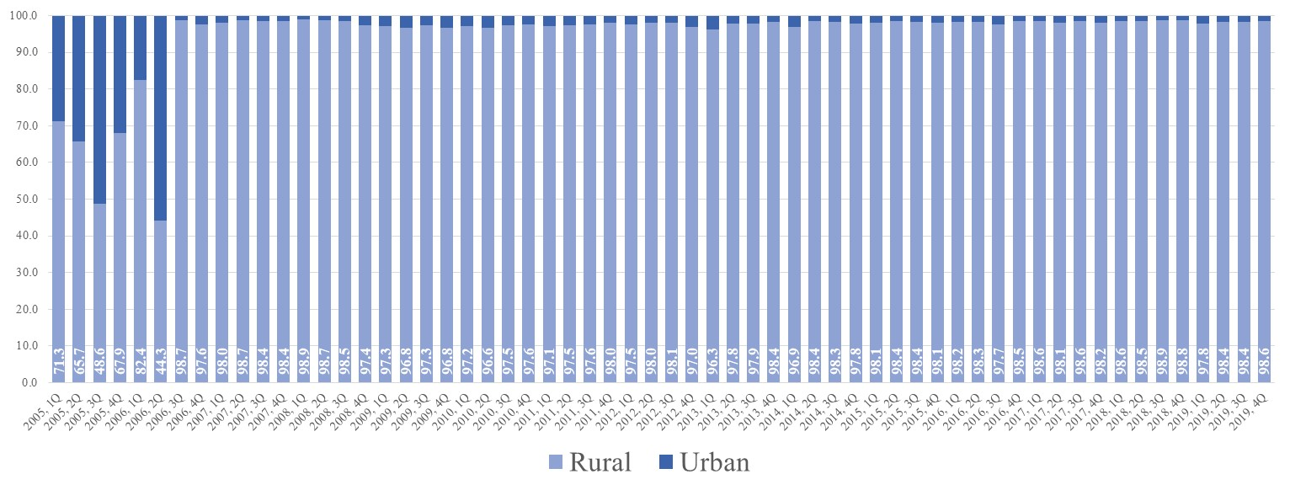

**Figure 13: Reasons for not working among working-age women (18–65) engaged in domestic chores,   
differentiated by locality size (Mexico, first quarter of 2019)**

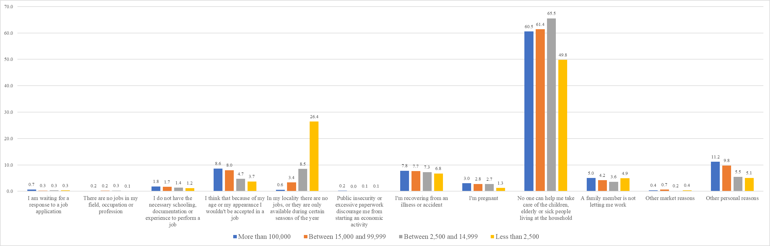

**Figure 14: Sectoral distribution of employment in relation to the population size of the locality (Mexico, first quarter of 2019)**

This exploratory data analysis suggests that the low FLPRs in Mexico’s agricultural municipalities could be related to the lack of demand for female labour in this sector. This could also be a potential explanation of why women from the lower socioeconomic stratum have lower FLPRs than women from middle and high socioeconomic strata. This might be judged an unusual result but, according to Lampietti and Stalker (2000), the lack of labour participation among poor women is common in Latin America. Therefore, a possible explanation for the low FLPRs among poor women in Mexico could be that the demand for a female labour force in the agricultural sector is particularly low.

This hypothesis is in line with Psacharopoulos and Tzannatos (1989), since they noted that subsistence activities and labour-intensive jobs in the agricultural sector tend to decline during the structural transformation process, generating a reduction in FLPRs. If this hypothesis is true, the results are suggesting that, even if the Mexican government were to implement a subsidised childcare programme in agricultural communities, FLPRs would not necessarily greatly increase, since the demand for female labour in rural areas of Mexico tends to be low.

# 6 Conclusions

Mexico is the Latin American country with the highest percentage of jobs in the industrial sector, while it also has one of the lowest FLPRs in the region. Since most studies have validated the U-shaped relationship between FLPRs and different stages of economic development, some of the assumptions and potential explanations of the pattern observed in cross-country analysis have been considered ‘stylised facts’, even without having been empirically evaluated. One of the main explanations for the downward portion of the U-shaped relationships is that middle-income countries are experiencing an expansion of the industrial sector, and women do not tend to work in blue-collar jobs, as there is a social stigma attached to these. This paper fills a gap in the literature by evaluating whether this specific hypothesis holds in Mexico. To do so, I have studied the within-country relationship between FLPRs and the sectoral distribution of employment using micro-data that provide empirical evidence at the local level.

The results obtained from this analysis reveal a number of different aspects. First, they show that one of the possible reasons behind the low levels of female labour participation in Mexico is the lack of labour participation among women living in agricultural municipalities. The exploratory data analysis showed that, in the first quarter of 2019, only 4% of the economically active women were working in the agricultural sector. Additionally, the scatterplots at both the state and municipal levels showed that female labour participation tends to decrease as the percentage of agricultural jobs increases. Finally, the probit regressions confirmed that having a higher percentage of agricultural jobs at the municipal level has a negative relationship with female labour participation even after controlling for other potential explanatory variables.

Regarding the role of the industrial sector on female labour participation, there are several papers indicating that women are usually excluded from participating in blue-collar jobs during the structural transformation process. For instance, Pampel & Tanaka (1986) posited that women are usually excluded from early industrial jobs as a result of physical limitations, gender discrimination and the domestic demands attached to higher fertility rates. Following the same argument, Goldin (1994) contended that in developing countries there is usually a social stigma that excludes women from participating in industrial jobs. Unfortunately, some researchers have assumed that the existence of a social stigma is a universal norm in developing countries. However, this paper found no evidence to conclude that there is a strong aversion towards women working in blue-collar jobs.

The exploratory data analysis shows that in 2019 about 16% of economically active women worked in the manufacturing sector, which is four times more than those engaged in agricultural activities. Moreover, the scatterplots at the state and municipal levels do not show the assumed negative relationship between FLPRs and a higher percentage of jobs in the manufacturing sector. Finally, the probit regressions showed that the existence of a higher percentage of jobs in the industrial sector has a positive relationship with female labour participation. This result is particularly relevant because it has important policy implications for Mexico. The cultural beliefs of each country are difficult to change and usually take a long time to uproot in a society. Fortunately, it seems that the social stigma towards women working in blue-collar jobs is not strong in Mexico, so implementing policies to increase FLPRs in the industrial sector may be easier than in other countries, where social norms are more influential and difficult to change.

The results also show that women have a greater likelihood of being economically active in municipalities with a higher percentage of jobs in this sector, which is in line with most of the literature on this topic. Nevertheless, there are additional aspects that could be analysed in the future. For instance, the theory indicates that the rise in FPLRs in service-oriented economies is a result of the absence of a social stigma towards white-collar jobs. However, this hypothesis fails to recognise that not all jobs in the service sector are white-collar jobs. Additionally, it should also be mentioned that the U-shaped feminisation hypothesis fails to recognise that in middle-income countries some of the jobs in the service sector are in the informal economy. In the case of Mexico, there are plenty of informal jobs in this sector even when the country, state or municipality is at the final stage of the structural transformation process. Therefore, it would be interesting to examine whether there are differences in FLPRs in formal and informal jobs in the service sector.

After exploring potential reasons for the findings and suggesting prospective research studies, I would like to conclude by emphasising the value of this research paper in the current body of literature on the topic. First, my research followed an innovative empirical strategy that can be replicated by other researchers. Following this micro-econometric approach can provide valuable empirical evidence of the within-country relationship between FLPRs and the sectoral distribution of employment. As mentioned above, one of the main advantages of this strategy is that making a within-country analysis using micro-data offers a level of disaggregation that cannot be replicated in cross-country analysis using macro-level data.

This research also suggests that the sectoral distribution of employment can be used as a proxy for the structural transformation process, and the results suggest that it is an explanatory variable of FLPRs. Finally, the research provides empirical evidence that contradicts some of the premises of the relationship between female labour participation and different stages of economic development. The results indicate that the sectoral distribution of employment at the local level affects FLPRs but not necessarily in the way that the theory indicates. This is particularly relevant given the lack of country-level studies evaluating these hypotheses and the lack of consensus on this topic.

It is important to note the main limitations of this research. The first is that this paper does not evaluate the U-shaped hypothesis in relation to historical trends. Perhaps it is true that, when Mexico was an agricultural country, FLPRs were particularly high. Nevertheless, the research has not tried to evaluate the U-shaped hypothesis from a long-term perspective. Instead, it studies the current relationship between sectoral distribution and female labour participation rates. Finally, it should be mentioned that the database used for this research is not representative at the municipal level. The empirical strategy section provides all the details of what was done to ensure that this would not be a problem for the analysis. However, the results need to be taken with caution, and additional robustness checks should be included in future versions of the paper.

# References

Afridi, F., Bishnu, M. and Mahajan, K. (2020). *Gendering Technological Change: Evidence from Agricultural Mechanization*. Social Science Research Network (SSRN) Scholarly Paper 3695413. https://papers.ssrn.com/abstract=3695413.

Bhalotra, S.R. and Fernández, M. (2021). *The Rise in Women’s Labour Force Participation in Mexico: Supply vs Demand Factors*. WIDER Working Paper 2021/16. Helsinki: WIDER. https://doi.org/10.35188/UNU-WIDER/2021/950-1.

Bloom, D.E., Canning, D., Fink, G. and Finlay, J.E. (2009). 'Fertility, female labor force participation, and the demographic dividend'. *Journal of Economic Growth* *14*, 79–101. https://doi.org/10.1007/s10887-009-9039-9.

Bloom, D.E. and Finlay, J.E. (2009). 'Demographic change and economic growth in Asia'. *Asian Economic Policy Review* *4*, 45–64. https://doi.org/10.1111/j.1748-3131.2009.01106.x.

Bloom, D.E. and Williamson, J.G. (1998). 'Demographic transitions and economic miracles in emerging Asia'. *World Bank Economic Review* *12*, 419–455. https://doi.org/10.1093/wber/12.3.419.

Borrowman, M. and Klasen, S. (2017). *Drivers of Gendered Sectoral and Occupational Segregation in Developing Countries*. Discussion Paper 222

Çağatay, N. and Özler, Ş. (1995). 'Feminization of the labor force: the effects of long-term development and structural adjustment'. *World Development* *23*, 1883–1894. https://doi.org/10.1016/0305-750X(95)00086-R.

Clark, R.L., York, A. and Anker, R. (2003). 'Cross-national analysis of women in the labour market'. In García, B., Anker, R. and Pinnelli, A. (eds), Women in the Labour Market in Changing Economies: Demographic Issues. Oxford: Oxford University Press.

Cuberes, D. and Teignier, M. (2018). *Macroeconomic Costs of Gender Gaps in a Model with Entrepreneurship and Household Production: The Case of Mexico*. Washington DC: World Bank Group.

Deshpande, A. and Singh, J. (2021). *Dropping out, Being Pushed out or Can’t Get in? Decoding Declining Labour Force Participation of Indian Women*. SSRN Scholarly Paper 3905074. https://doi.org/10.2139/ssrn.3905074.

Falk, M. and Leoni, T. (2010). 'Regional female labour force participation: an empirical application with spatial effects'. In Caroleo, F.E. and Pastore, F. (eds), *The Labour Market Impact of the EU Enlargement: A New Regional Geography of Europe?* (pp. 309–326). Heidelberg: Physica-Verlag.

Gaddis, I. and Klasen, S. (2014). 'Economic development, structural change, and women’s labor force participation: a reexamination of the feminization U hypothesis'. *Journal of Population Economics* *27*, 639–681. https://doi.org/10.1007/s00148-013-0488-2.

Goldin, C. (1994). *The U-shaped Female Labor Force Function in Economic Development and Economic History*. National Bureau of Economic Research (NBER) Working Paper 4707. Cambridge MA: NBER. https://doi.org/10.3386/w4707.

Heath, R. and Jayachandran, S. (2016). *The Causes and Consequences of Increased Female Education and Labor Force Participation in Developing Countries*. NBER Working Paper 22766. Cambridge MA: NBER. https://doi.org/10.3386/w22766.

INEGI (2015). 'Clasificaciones ENOE' [available at: https://www.inegi.org.mx/contenidos/programas/enoe/15ymas/doc/clasificaciones_enoe.pdf].

INEGI (2020). *Cómo se hace la ENOE: Manual de métodos y procedimientos*. Page 66.

Kaplan, D. and Piras, C. (2019). 'Brechas de género en el mercado laboral mexicano: comparaciones internacionales y recomendaciones de política pública'. *Revista de Economía Mexicana* *4*, 28.

Klasen, S. (2019). 'What explains uneven female labor force participation levels and trends in developing countries?'. *World Bank Research Observer* *34*, 161–197. https://doi.org/10.1093/wbro/lkz005.

Klasen, S., Le, T.T.N., Pieters, J. and Santos Silva, M. (2021). 'What drives female labour force participation? Comparable micro-level evidence from eight developing and emerging economies'. *Journal of Development Studies* *57*, 417–442. https://doi.org/10.1080/00220388.2020.1790533.

Lahoti, R. and Swaminathan, H. (2016). 'Economic development and women’s labor force participation in India'. *Feminist Economics* *22*, 168–195. https://doi.org/10.1080/13545701.2015.1066022.

Lampietti, J.A. and Stalker, L. (2000). 'Consumption expenditure and female poverty: a review of the evidence'. Working Paper 11 (Gender and Development), Development Research Group.Washington DC: World Bank.

López-Acevedo, G., Freije-Rodríguez, S., Vergara Bahena, M.A., Cardozo Medeiros, D., López-Acevedo, G., Freije-Rodríguez, S., Vergara Bahena, M.A. and Cardozo Medeiros, D. (2021). 'Changes in female employment in Mexico: demographics, markets and policies'. *Estudios Económicos* (México, D.F.) *36*, 115–150. https://doi.org/10.24201/ee.v36i1.411.

Luci, A. (2009). 'Female labour market participation and economic growth'. *International Journal of Innovation and Sustainable Development* *4*. https://doi.org/10.1504/IJISD.2009.028065.

Mammen, K. and Paxson, C. (2000). 'Women’s work and economic development'. *Journal of Economic Perspectives* *14*, 141–164. https://doi.org/10.1257/jep.14.4.141.

Pampel, F.C. and Tanaka, K. (1986). 'Economic development and female labor force participation: a reconsideration'. *Social Forces* *64*, 599–619.

Perkins, D.H., Radelet, S., Lindauer, D.L. and Block, S.A. (2013). *Economics of Development*. New York: W.W. Norton.

Psacharopoulos, G. and Tzannatos, Z. (1989). 'Female labor force participation: an international perspective'. *World Bank Research Observer* *4*, 187–201. https://doi.org/10.1093/wbro/4.2.187.

Tam, H. (2011). 'U-shaped female labor participation with economic development: some panel data evidence'. *Economics Letters* *110*, 140–142. https://doi.org/10.1016/j.econlet.2010.11.003.

Verick, S. (2014). *Female Labor Force Participation in Developing Countries*. Institute of Labour Economics (IZA) World of Labor [available at https://doi.org/10.15185/izawol.87].

# Appendix

## Table A1: Descriptive statistics

## Figure A1: Control variables

*FLPRs considering different levels of education (2005–2019)*

*FLPRs and marital status (2005–19)*

*FLPR depending on socio-economic stratum (2005–19)*

*FLPRs in relation to number of children (2005–19)*

*FLPRs in rural and urban areas (2005–2019)*

*FLPRs related to population size of the localities (2005–19)*

**Figure A2: FLPRs and share of employment in the agricultural sector across countries (2019)**

**Figure A3: FLPRs and share of employment in the industrial sector across countries (2019)**

**Figure A4: FLPRs and share of employment in the service sector across countries (2019)**

**Figure A5: Percentage of agricultural jobs in Mexican states (first quarter of 2019)**

**Figure A6: Percentage of industrial jobs in Mexican states (first quarter of 2019)**

**Figure A7: Percentage of service jobs in Mexican states (first quarter of 2019)**

1. Ph.D. Candidate in Development Policy & Management, Global Development Institute, University of Manchester, UK.